**Project Report: Creating a Netflix Home Page Clone Using HTML and CSS**

**Introduction**

This project aimed to replicate the Netflix home page using HTML and CSS, focusing on understanding web design principles, layout techniques, and responsive design. The goal was to create a visually appealing and functional interface that mirrors the essential features of the Netflix platform.

**Objectives**

* To understand and implement HTML structure for a web page.
* To utilize CSS for styling and layout design.
* To explore responsive design techniques to ensure compatibility across different devices.
* To enhance skills in front-end web development.

**Tools and Technologies Used**

* **HTML5**: For structuring the content of the web page.
* **CSS3**: For styling and layout design.
* **Responsive Design**: Media queries and flexible grids for adaptation to various screen sizes.
* **Code Editor**: Visual Studio Code for writing and testing the code.

**Project Structure**

**1. HTML Structure**

The HTML structure was organized into several sections, including:

* **Header**: Contains the logo and navigation links.
* **Main Content**: Features the movie/carousel section, including featured shows and categories.
* **Footer**: Contains links and copyright information.

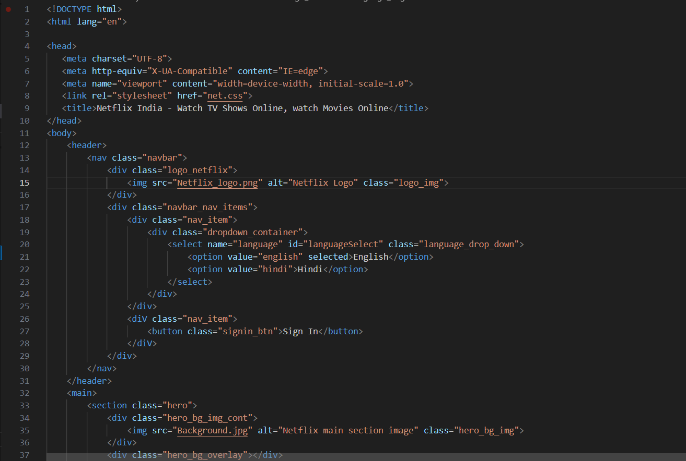

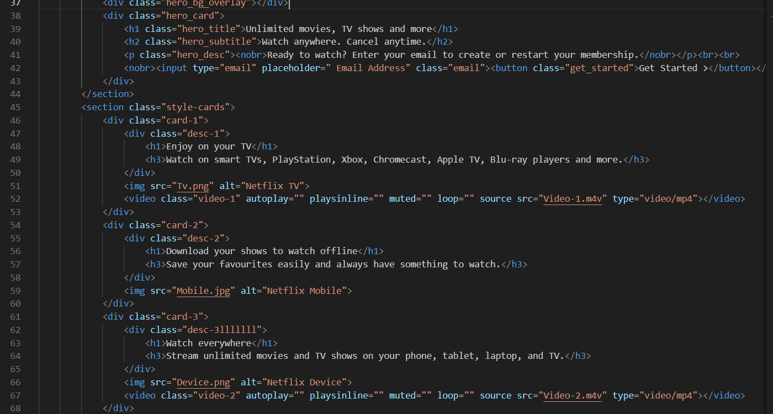

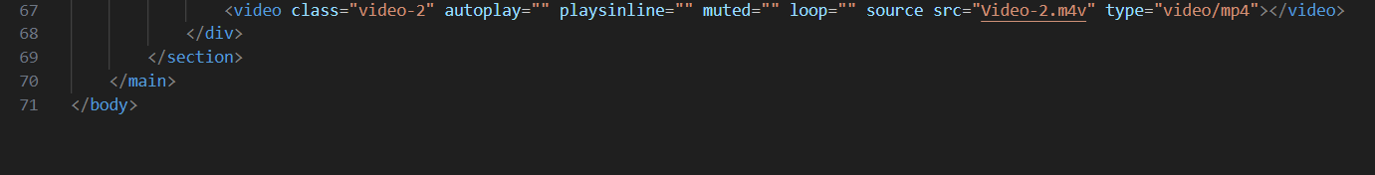

**2. CSS Styling**

The CSS file was used to apply styles, including colors, fonts, layout, and responsive design features.

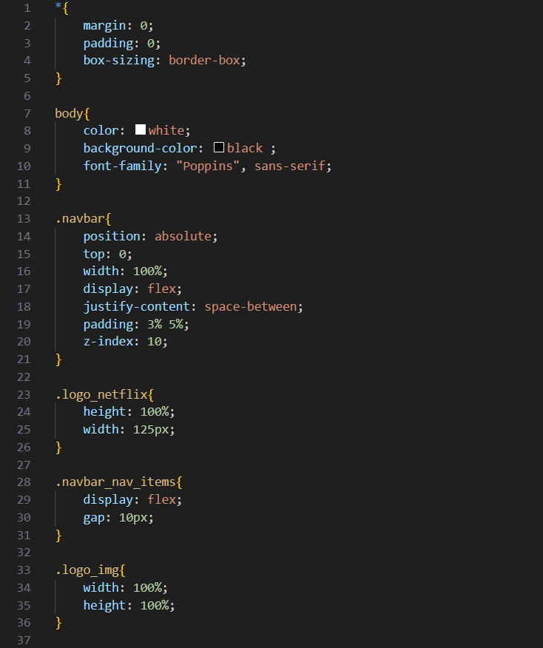

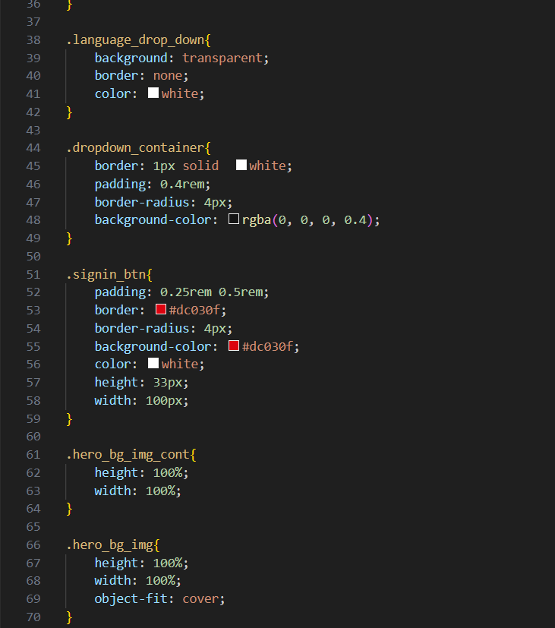

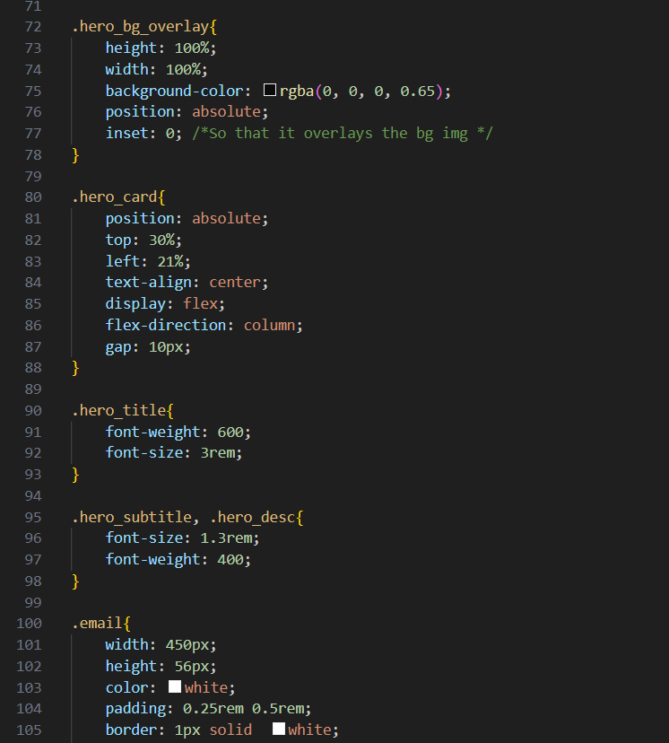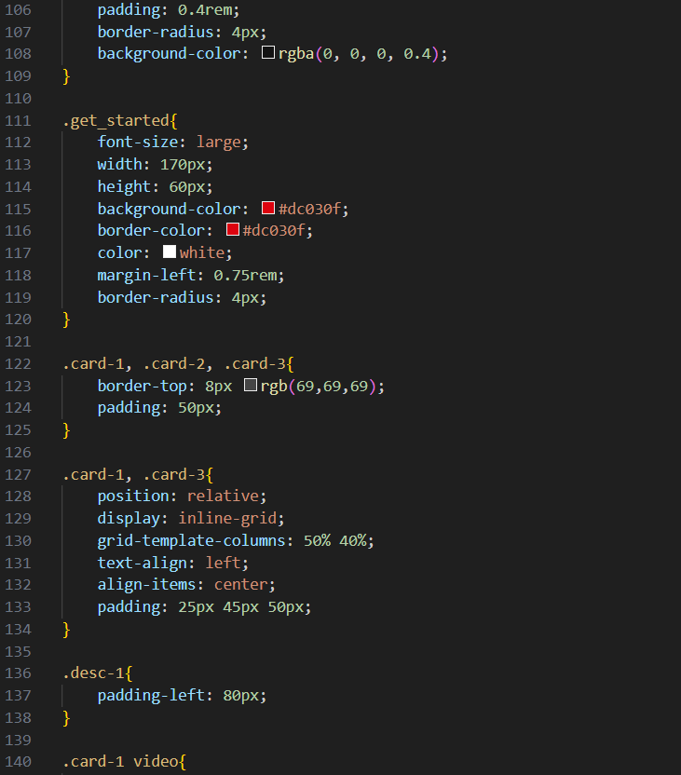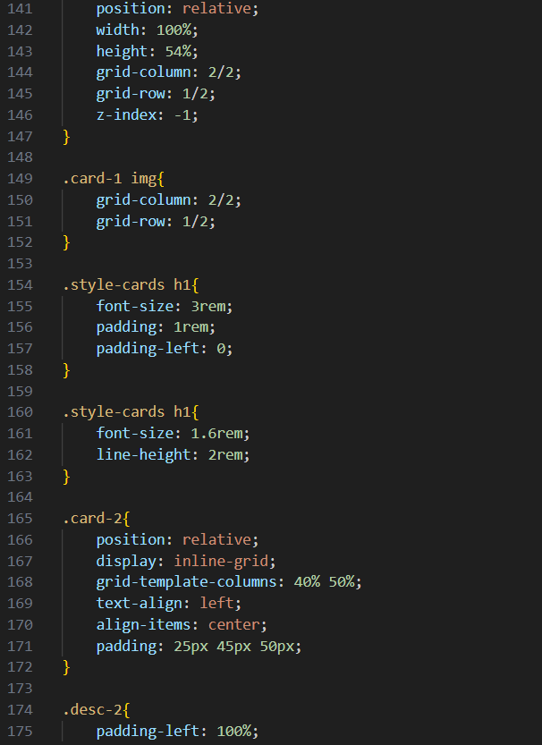

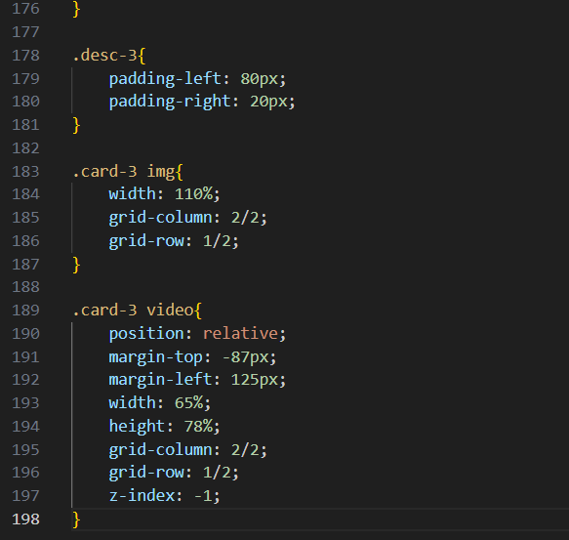

**Implementation Details**

**Layout and Design**

* The layout was designed to be simple yet effective, using a flexbox model for alignment.
* The carousel section showcased movie thumbnails in a horizontally scrollable format, simulating the Netflix browsing experience.
* Color schemes and fonts were chosen to replicate the Netflix aesthetic, focusing on a dark theme with bright accent colors.

**Responsive Design**

* Media queries were implemented to adjust the layout for different screen sizes.
* The navigation menu changes from horizontal to vertical on smaller screens, enhancing usability on mobile devices.

**Challenges Faced**

* Achieving a smooth scrolling effect for the carousel section required careful use of CSS properties.
* Ensuring that the design was responsive across various devices necessitated thorough testing and adjustments.

**Conclusion**

The project successfully achieved its objectives by creating a functional clone of the Netflix home page using HTML and CSS. This experience enhanced skills in front-end development, including layout design, responsive techniques, and overall web aesthetics. Future improvements could involve adding JavaScript for interactivity and implementing a more complex grid layout for the movie categories.

**Future Work**

* Integrate JavaScript for dynamic content loading and interaction.
* Expand the project to include user authentication features.
* Explore advanced CSS techniques, such as animations and transitions, for a more engaging user experience

This report summarizes the project's goals, implementation, and outcomes, providing a foundation for further development and learning in web design and development.

Anmol Kumar

## 220029010027